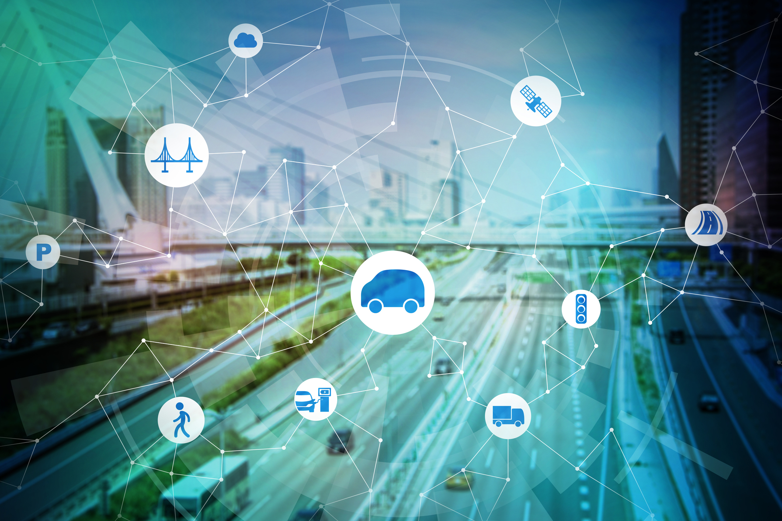

REG.NO:- 2022-TE-11 ASSIGNMENT OF ICT

# ROLE OF PROGRAMMING IN COMMUNICATION TECHNOLOGY IN TRANSPORT:-

* Information and communication technologies (ICTs) have considerable importance for transport systems, as they provide access to travel information, planning tools, opportunities to share transport modes, to work at-a-distance, compare transport mode cost, make payment, improve safety and health, and to communicate travel patterns. Over the past decade, there has been massive growth in the availability of transportation ICT, in particular, smartphone applications. There is considerable evidence that ICTs have profoundly changed the ways in which transport systems are perceived and used, and mobilities performed, with far-reaching implications for transport mode choices and transport demand. Against this background, the paper seeks to conceptualize ICT with relevance for transport systems, and to discuss the implications for the environmental sustainability of the transport sector.
* Information and communication technology (ICT) has been a part of global life and also has a positive impact on human welfare. ICT involves activity, hardware, and electronic software that execute processing, transmission, and displaying information. This study aims to investigate the impacts of ICT on economic welfare. The data used were from the World Development Indicators of the World Bank for 82 countries during 2009 through 2017.

ROLE OF ICT IN SHIPPING INDUSTRY

* Python is one of the most powerful programming languages today. It’s a key tool for a variety of enterprise-grade applications. And seeing as how investing in state-of-the-art freight forwarding solutions is important for logistics companies seeking success, Python developers are more valuable than ever before.
* Moreover, Python developers have the unique ability to refine shipping systems, making them more accurate and reliable. With such a system, shipping companies can easily manage their deliveries and make sure that everything arrives in the right place at the right time.
* Besides more accurate management, plenty of shipping systems nowadays also feature [shipping route maps](https://www.sofarocean.com/posts/7-tools-for-selecting-better-shipping-routes) that plot out the best course for shippers to take. This enables companies to find the swiftest and safest routes for a better shipping experience for their customers and their employees.
* some other roles that a python developer may play in the shipping industry:
* Refine activity logs
* Organize company server architecture
* Simplify complicated freight-forwarding systems
* Build scalable web applications
* Collect and analyze industry data

## CONCLUSION:-

The role of Information and Communication Technology (ICT) in the transport industry has been transformative and continues to have a significant impact on various aspects of transportation. ICT has revolutionized how we manage and operate transportation systems, improving efficiency, safety, and convenience.